**Topic: Airline management system**

**Group member name ID**

SAHA, ATANU 18-38429-2

TAZ, NIAMUL BASHAR18-38452-2

MUSHARRAT, SAUDA16-32571-2

UMME NUSRAT TRISNA 17-35366-3

**Contents**

1. **Paragraph………………………………………………….. 3**
2. **Entity relationship diagram………………………... 4**
3. **Final tables………………………………………………… 5**
4. **Table creation……………………………………………. 6-7**
5. **Insertion……………………………………………………. 8-9**
6. **Constraints………………………………………………… 10**
7. **Query…………………………………………………………. 10**

**Paragraph:**

Emirates is a airline company that provides air transport services. In order to book a flight, a passenger has to provide his/her name, DOB (date of birth), nationality, passport no, email. After providing these information, a passenger can book a flight. Specific booking details are set for a passenger which contains booking id, class, seat no, price. By using these booking details a flight is assigned. There may be one flight for many booking details. A flight has details of flight no, route, duration, departure time, stoppage. Every flight has a specific airplane containing A_id, type. Every airplane is served by many employees. Every employee has information such as E_id, name, salary, hire date, job.

**Entity Relationship Diagram :**

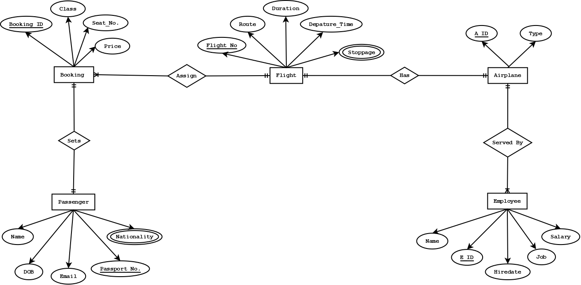**Final Tables:**

|  |  |  |  |  |  |
| --- | --- | --- | --- | --- | --- |
| PASSPORT_NO | NAME | NATIONALITY (multivalued) | DOB | EMAIL | BOOKING_ID |
|  |  |  |  |  |  |
|  |  |  |  |  |  |

|  |  |  |  |
| --- | --- | --- | --- |
| BOOKING_ID | SEAT_NO | FLIGHT_NO | CP_ID |
|  |  |  |  |
|  |  |  |  |

|  |  |  |
| --- | --- | --- |
| CP_ID | CLASS | PRICE |
|  |  |  |
|  |  |  |

|  |  |  |  |  |
| --- | --- | --- | --- | --- |
| FLIGHT_NO | DEPARTURE_TIME | STOPPAGE  (multivalued) | D_ID | A_ID |
|  |  |  |  |  |
|  |  |  |  |  |

|  |  |  |
| --- | --- | --- |
| D_ID | DURATION | ROUTE |
|  |  |  |
|  |  |  |

|  |  |  |  |  |  |
| --- | --- | --- | --- | --- | --- |
| E_ID | NAME | JOB | SALARY | HIREDATE | A_ID |
|  |  |  |  |  |  |
|  |  |  |  |  |  |

|  |  |
| --- | --- |
| A_ID | TYPE |
|  |  |
|  |  |

**Table Descriptions:**

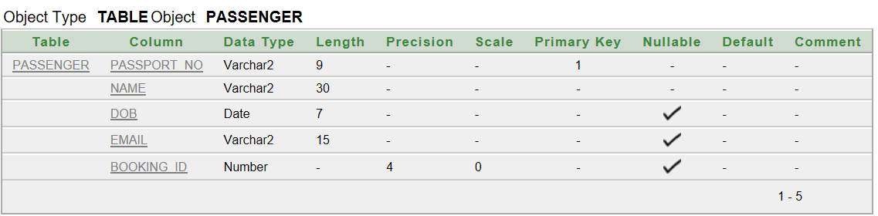

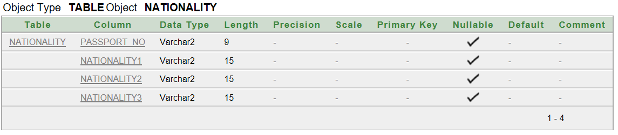

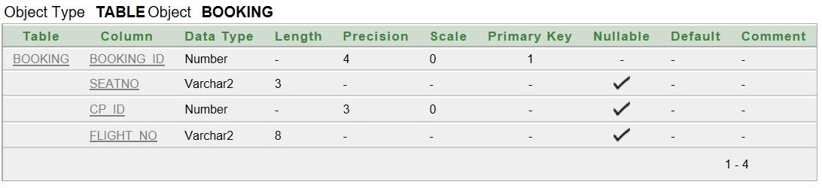

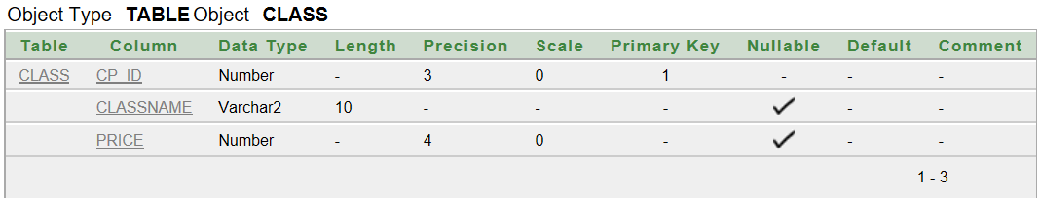

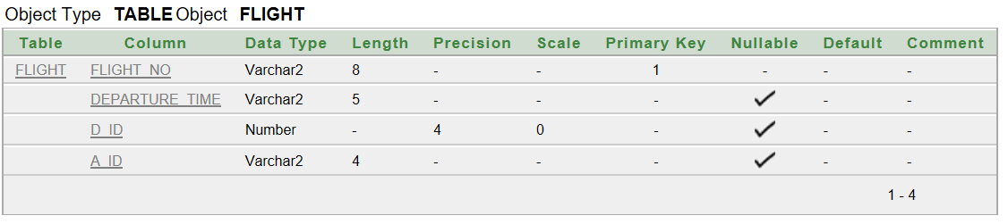

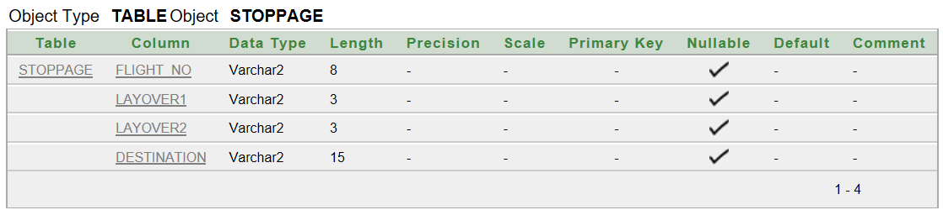

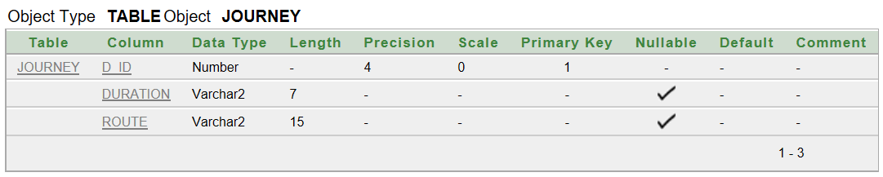

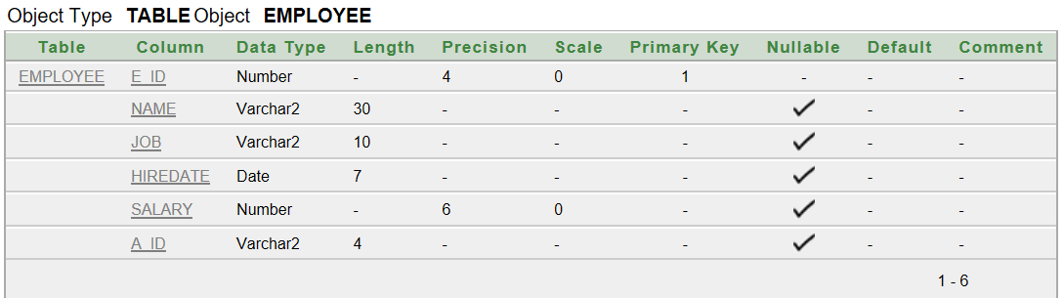

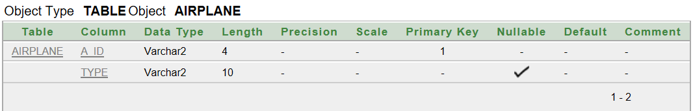

**Insertion:**

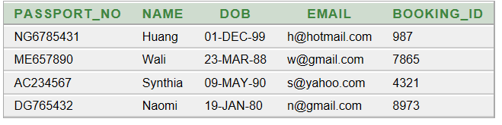

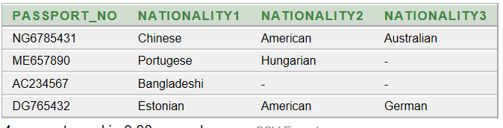

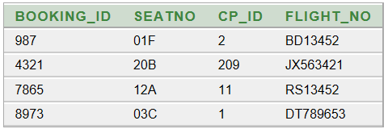

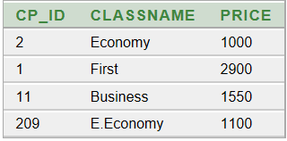

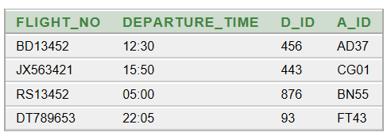

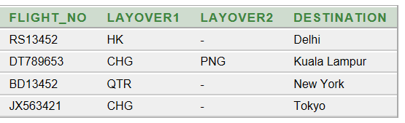

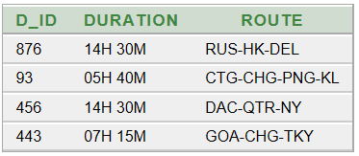

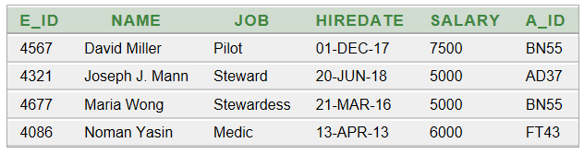

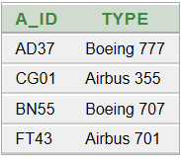

**Constraints:**

1. In passenger table email is unique.
2. In booking table seat no is unique.
3. In Airplane table the default value of type is airbus 355.

**Query:**

1. Find the airplane classes which have price range of 1000 to 2000.
2. Show the nationality information of passengers. Those who have null display ‘Not Applicable’ and name the column “Nationality Info”.
3. Find name and passport no of whose nationality is Chinese.
4. Find the flight no of passenger named Synthia.
5. Write a query to display the total number of employees in airplane BN55.
6. Write a query to display the average salary of employees serving in each airplane who earn more than 4000.
7. Display the name and salary who has a salary greater then employee_id 4677.
8. Display the name and job who has a employee_id 4567 and salary greater then employee_id 4677.
9. Create a view and display name, job whose salary is greater than 5500.
10. Create a view and display name, job and salary whose employee id is 4567.